Lab 2 – Diode Measurements and Analysis

CE-3101/021 Digital Elex. and Comp. Interfacing

By:

Andrew Iliescu

4-5-2020

**Abstract:**

Doing circuit analysis has become easier than ever before thanks to programs and technologies which allow people to build and test circuits. Such tools like the Analog Discovery kit and the Waveform generator program allow people to build circuits with physical components and then test them under various conditions. In this lab we used the Analog Discovery kit to build a circuit and then graph the voltages along some of its components to then calculate the remaining components unknowns. This was then repeated on various conditions such as changing the input voltage and frequency and even swapping out one of the unknown components.

**Methods:**

Figure 1: Circuit diagram, taken from Ms.Varnell’s CE3101 Lab 2 document

The circuit in figure 1 was built on a breadboard and then analyzed using the waveforms program. First the voltage source was a ramp at 100kHz from 0V to 1V. Then the voltage source was reconfigured as a square wave and again the data was collected. Next the diode was switched out from the 1N4148 model to the 1N4007 model and the square wave between the two diodes was compared. Then the voltage source is tuned to 50Hz and the square wave for the 1N4007 diode is again displayed. Then the ramp voltage source at 50Hz is measured against the 1N4007 diode and the graph is again inspected. From the ramp results for both diodes we can calculate the voltage across those diodes using Ohm’s Law, Kirchhoff’s Laws, and our given knowns for the resistor and voltage source

**Results:**

After conducting the lab, we were able to collect all of the data necessary to calculate the unknown quantities and see the difference in results between the two diodes. We first started off with the 1N4148 diode at 100kHz as the voltage source ramped up from 0V to 1V. The resulting graph is displayed in figure 2. We gathered the data by configuring the scope of the channels to have a range value of 500mV/div while the function got sampled every 2s.

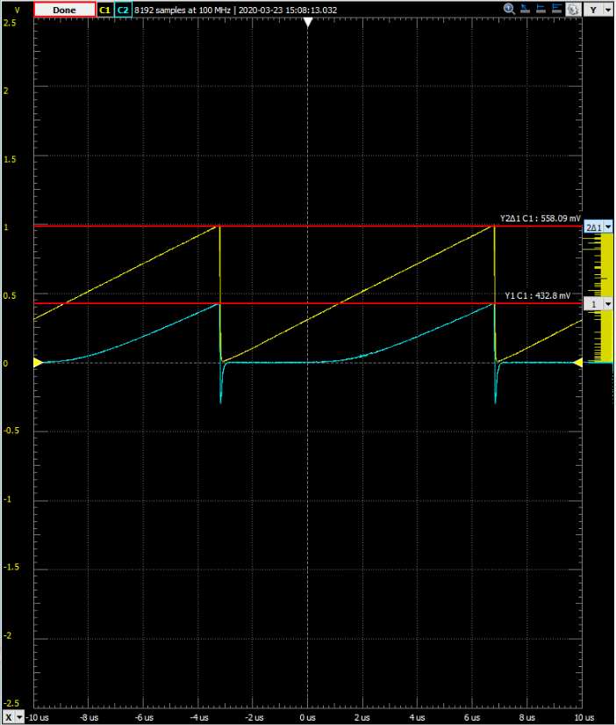

Figure 2: Results from 100kHz ramped up voltage on figure 1 circuit with 1N4148 diode

After gathering the data from this graph, the voltage across the diode can be calculated by using KVL and the two-known voltages across the resistor and source. This allowed us to plot the current vs the voltage. The current was known through Ohm’s Law because there is only one loop in the circuit meaning that the current is the same for each component. So, by using the known resistor voltage and resistance we can calculate the current through the resistor and use that same current in the ID vs. VD graph in figure 3.

Figure 3: Graph of the current vs voltage for the 1N4148 diode at 100kHz ramp voltage

Next in the lab we changed the voltage from a ramp up to a square wave and the subsequent result is shown in figure 4.

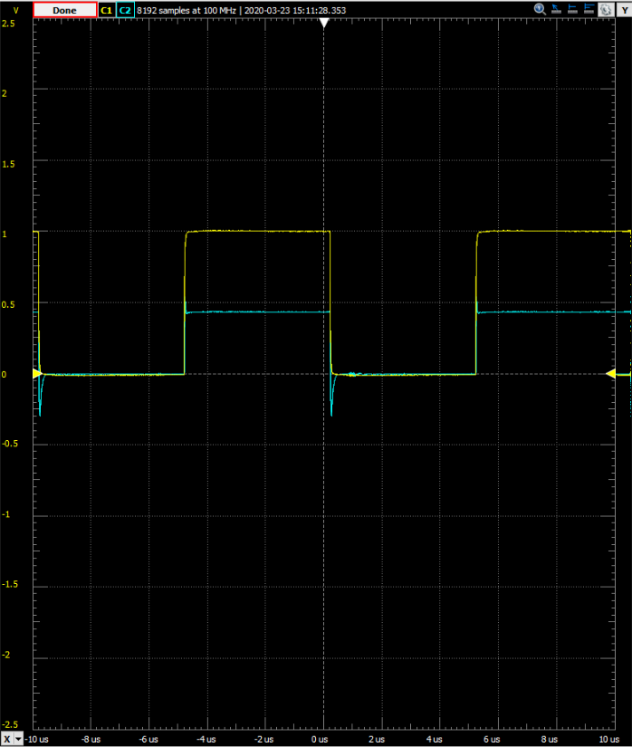

Figure 4: Results from 100kHz square wave voltage on figure 1 circuit with 1N4148 diode

From the square wave we can see that the 1N4148 diode is a fast switching diode because it is keeping up with the frequency. Fast switching diodes are widely used for many applications because they quickly recover from a sudden bias flip. Next we tested a 1N4007 diode which is a rectifier diode which doesn’t switch as fast. Figure 5 demonstrates this lack of speed.

Figure 5: Results from 100kHz square wave voltage on figure 1 circuit with 1N4007 diode

In order to adjust for this the frequency is down scaled to 50Hz. The reason the diode can’t keep up is because rectifier diodes are designed with the intention to provide much higher currents. This means that they are typically found in power supplies. Once we adjusted the frequency to 50Hz we can see (figure 6) the nice square wave results because now the diode can keep up and the circuit runs seamlessly.

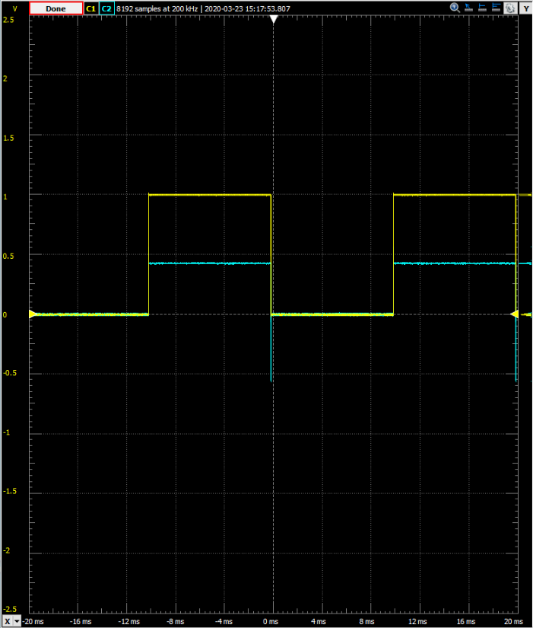

Figure 6: Results from 50Hz square wave voltage on figure 1 circuit with 1N4007 diode

We then went ahead and redid the ramp up voltage at a frequency of 50Hz for the circuit with the 1N4007 diode. The result is shown in figure 7. The data gathered from figure 7 helps us calculate the voltage across the diode using KVL. Then we can again use Ohm’s Law in order to calculate the current across the resistor and since there is only one closed loop in the circuit, that means that the same current flows through the diode. This allows us to plot the current against the voltage for the circuit with the 1N4007 diode as well (figure 8).

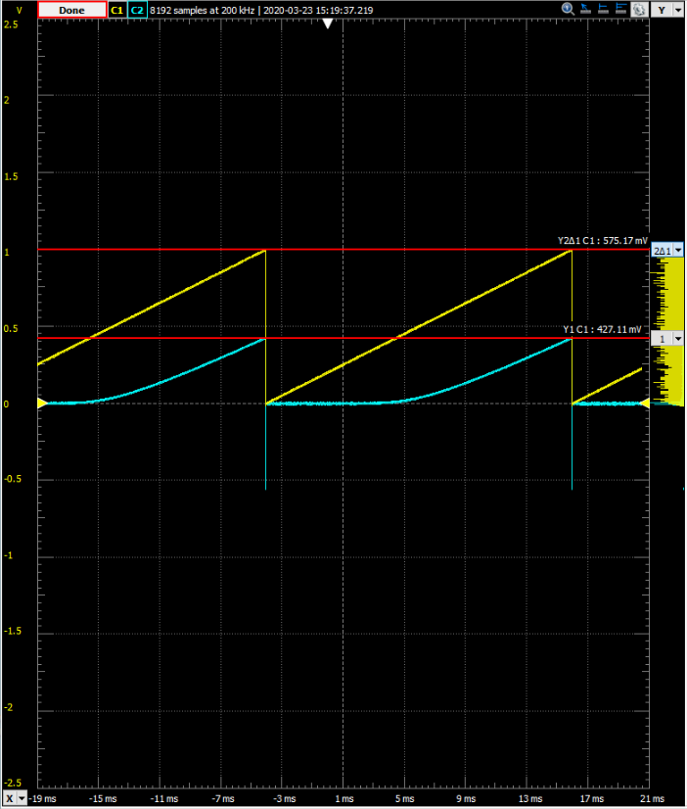

Figure 7: Results from 50Hz ramp up voltage on figure 1 circuit with 1N4007 diode

Figure 8: Graph of the current vs voltage for the 1N4007 diode at 50Hz ramp voltage

Now the lab also posed some questions which need to be answered, and these are:

1. **Compare the ID versus VD curves of both diodes. How are they similar? How do they differ?**

The graphs for both of the circuits with each diode are exponential and they both span around the same current and voltage values. However, they differ because the circuit with the 1N4148 diode requires approximately one thousand values for one period whereas the circuit with the 1N4007 diode requires approximately four thousand values.

1. **Compare the current through the 1N4148 diode when V1 = 1V to the pre-lab calculations. How different are the values?**

According to the graph when the circuit with the 1N4148 diode is at 1V the current in the circuit is approximately 432A and the calculations done in the pre-lab reported that the current should be approximately 424A. This is a difference of about 1.9% between the two values.

**Summary:**

After conducting this lab and going through the directions step by step, the most important results are as follows: we can calculate the voltage through a diode by using KVL, we can calculate current using Ohm’s Law, we can plot current against the voltage to see how a diode impacts a circuit over long periods of time, and we can see how different diodes react under different voltage inputs and different frequencies.

**Appendix:**

No items to present.